**Calibration Curve – Using the Beer Lambert Law**

1. A series of solutions with known concentrations of KMnO4 were prepared and the absorbance of each solution was measured at an appropriate wavelength. This data was used to construct the calibration curve shown.

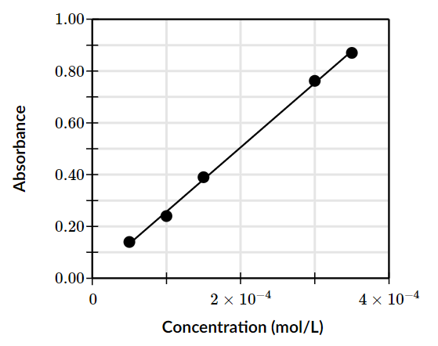

1. **Calculate** the concentration of KMnO4 in an unknown solution with an absorbance of 0.50.
$$c≈2×{10}^{−4}=0.0002 \text{mol}\text{/}\text{L}$$

2. **Calculate** the number of moles of KMnO4 contained in a 150 mL sample of the unknown solution.
$$=3×{10}^{−5} \text{mol}$$

3. The phosphate content of the water of a contaminated lake was analysed using UV–visible spectroscopy. In one analysis, a 25.0 mL sample of lake water was placed in a 250 mL volumetric flask and made to the mark with distilled water.

The solution was treated with a small volume of sodium molybdate solution to form a blue-coloured phosphorus compound.

A 5.00 mL sample was taken and recorded an absorbance of 0.60 at a wavelength of 600 nm. A calibration curve, shown below, was constructed using five standard phosphate solutions.

**Use** the calibration curve shown to **calculate** the concentration of phosphate in the water.

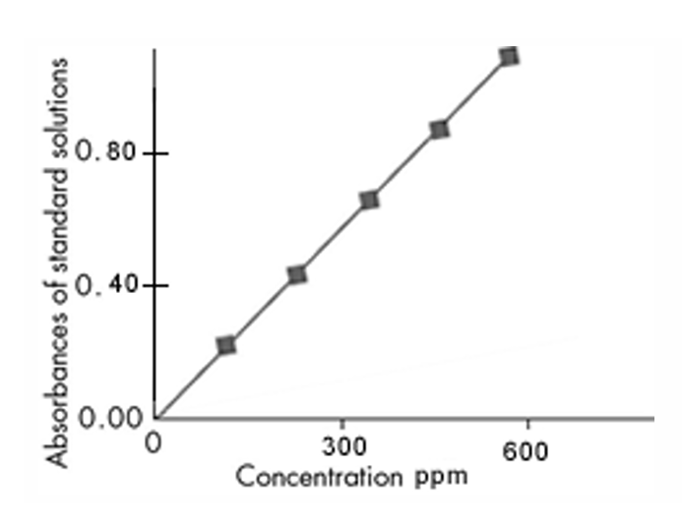

1. What is the Beer Lambert law? Write down the equation and label the symbols (include units).

According to the Beer-Lambert Law, the concentration of metal ions in a solution is proportional to the absorption of light. The equation is: $$A=εdc$$  
Where:

* A is the absorption of light
* $$ε$$ is the molar absorptivity constant
* $$d$$ Is the distance travelled by light
* $$c$$ Is the concentration of metal ions

1. **Explain** how the absorbance of a solution would be affected if the concentration of a solution was reduced by half.
2. A volumetric flask can be used to make stock solution and create a series of dilutions. A volumetric pipette is used to transfer stock solution into a volumetric flask. When diluting the solution, distilled water was added to just above the mark.

a) **Explain** the affect this has on the concentration of the solution in the flask. Will the concentration be higher or lower than desired?

b) **Determine** whether you could use the prepared solution or whether you would need to start over. **Explain** your answer with reference to experimental error.

1. A chemist was trying to prepare 500.00 mL of 1.90 × 10-4 M Allura Red (MW 496.42 g/mol). **Calculate** the mass in grams of Allura Red required.
2. The molarity of Allura Red in a stock solution is 1.90 × 10-4 M. 5.00 mL of this solution is placed into a 100.00 mL volumetric flask and filled to the mark with distilled water. **Determine** the concentration of the diluted solution.